Introduction
The GenePattern server provides a stand alone method for current caIntegrator apps to get free analytical tools to run against large datasets of interest. Since it is free, reusable, has the ability to easily add modules, and currently works with caIntegrator1 applications, it serves as a good starting point for analytical tools for caIntegrator2. This document will review how we currently use the Gene Pattern server as well as go over the challenges we will face.

Current Methodology
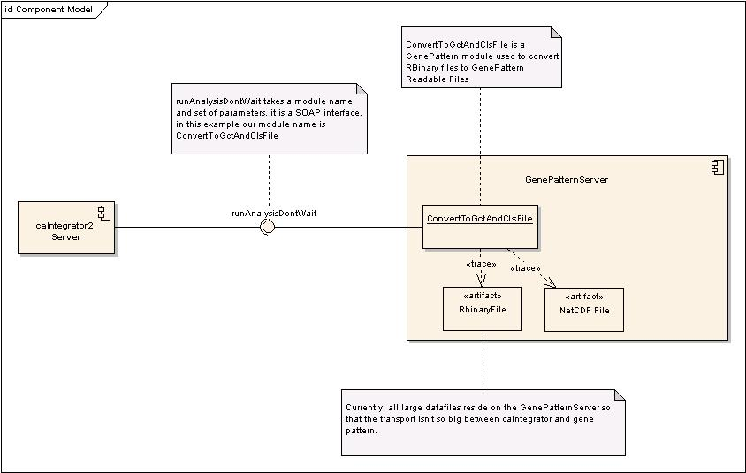

As you can see above, the Gene Pattern server currently sits on its own separate server apart from other caIntegrator products that use it. The High Throughput Data resides on the GenePattern server in the form of RBinary files, this is so that it doesn’t have to send the large datasets back and forth. It uses a SOAP interface to communicate, and the method here is runAnalysisDontWait(). This interface takes in two parameters, a module name and a set of parameters for that given module. In our example, the module name is ConvertToGctAndClsFile. The parameters, as an example, are as follows:

input.filename1=C:\DOCUME~1\tandrews\LOCALS~1\Temp\labIdsFile45113.txt
input.filename2=C:\DOCUME~1\tandrews\LOCALS~1\Temp\reproterIdsFile45114.txt
project.name=trwb
array.filename=SNP100K.nc
annotation.filename=TCGA_Exp_AffyHGU133.broad.05SEPT07_annot.Rda
analysis.name=tester
output.cls.file=tester.cls
output.gct.file=tester.gct

Let me go over these inputs one by one. First the input.filename1 and 2 are the input files of the reporter Ids and sample Ids of interest. These files are created on the fly after specific lists of interest have been selected and then sent over to the Gene Pattern server. The project name is self explanatory, it would be the study in our case. The array.filename is the name of the file that would be on the server that needs to be converted to cls and gct format. This filename comes from the local CGOM database based on the Array Platform that was used (each platform only currently has one file associated with it per study). The annotation filename also comes from the CGOM database, one annotation file per array file. The analysis.name is what we named the job, that is given by user. And then the 2 output files are what will be saved for the user to run analysis on.

So basically after a client sends over the job, it will get a task ID. When the analysis server finishes the module run it will notify the client that that job is complete and the user can then click over to the Gene Pattern page and it will display the 2 converted files available for the many analysis tools to use.

Our Challenges
There are quite a few unique challenges that caIntegrator2 will have because of how we are going to use dynamic data models and changing high throughput datasets.

- After we pull data over from caArray, where does it get stored?
  - I suppose we store a local copy and send another copy over to gene pattern server so that they can do local analysis on that data. Probably need to look into how the rbinary files are stored / created currently for caIntegrator products.
- If we use NetCDF or another format, we will need to write modules for that.
- We need to modify CGOM model somewhat to account for a new use case. The old assumption was that one platform had one file, the new method may not be based on Platform at all, and there can probably be more than one file per study, how will we deal with multiple files per study?
- When a study gets updated, we need to synchronize data on both our server as well as the gene pattern server (and any other servers we decide to use, like geWorkbench).
- Are we going to store all annotation values of reporters and samples in our local database for all studies? Currently each caIntegrator product has tables that have reporters as well as the reporters to gene mappings. There are also samples mapped to participants.

Conclusion
We can use the same architecture that other caIntegrator products use to get Gene Pattern to work, however the challenges stated above need to be hammered out before it works properly.

